**UID/UX ASSIGNMENT - 1**

**SANGAMITHRAN.A**

**CSE – C**

**230701283**

* **BAD DESIGN PROTOTYPE:**

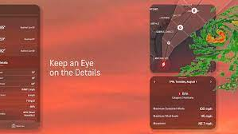

* **GOOD DESIGN PROTOTYPE:**

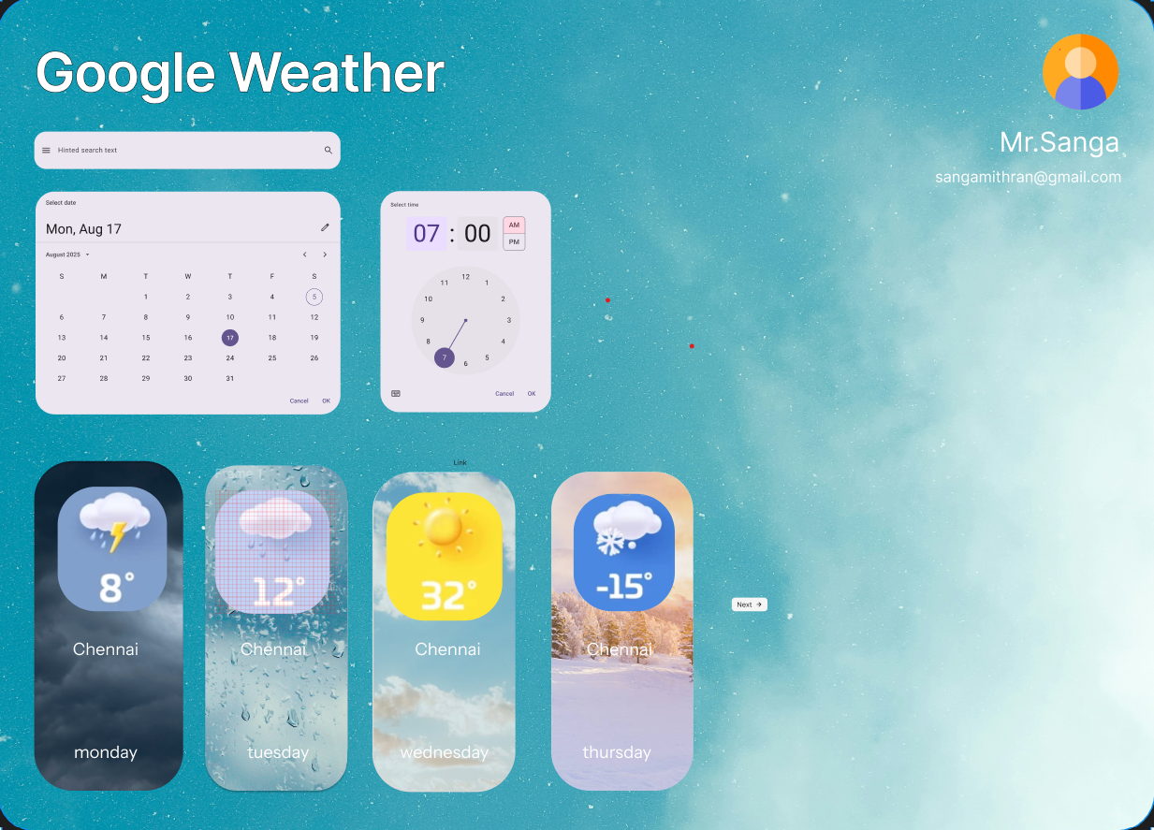

**Comparison of UX and UI Design in Two Figma-Based Website Layouts**

**1. Introduction**

**The two images are website designs made using Figma. One is a good UX/UI design, while the other has several design flaws that affect usability and aesthetics. This document compares both in terms of user experience (UX), frontend color scheme, typography, layout, navigation, and responsiveness.**

**2. Good Design (Second Image )**

**UX and UI Strengths:**

**Modern and Elegant Aesthetic: The design follows a minimalist yet sophisticated approach, using ample white space and a well-structured layout.**

**Readable Typography: The fonts are bold and stylish, with a good balance of modern and elegant typefaces. The main heading stands out.**

**Effective Color Contrast: The dark maroon theme with white text ensures readability, making the content visually appealing.**

**Engaging UI Elements: Using arrows and call-to-action buttons like makes for better navigation.**

**Consistent Design Language: The whole page is uniform and displays a professional look, which leaves minimal distractions and ensures brand consistency across the board.**

**Well-structured content blocks: Content is well-separated with distinct sections to scan easily by users.**

**Possible Improvement Areas**

**Hero section's text block should have had better spacing to enhance readability.**

**Some buttons should be more obviously active on hover.**

**3. Poor Design**

**UX and UI Weaknesses:**

**Outdated Aesthetic: The design feels cluttered and lacks a modern touch.**

**Poor Typography Choices: The cursive font in the logo is difficult to read, and the text alignment is inconsistent.**

**Weak Color Scheme: The pastel green background does not contrast well with the text, making readability an issue.**

**Overcrowded: Too many components crammed, creating visual overkill.**

**Irregular Button Shape: The donation button is in contrast but the overall theme mismatched.**

**Bad Navigation: Bar exists but little spacing between any of the component makes it compact.**

**Possible Amendments:**

**Minimize the present design to incorporate more modernist style.**

**Try to improve more on color and contrast for improving readability.**

**Design better typography based on clear font, sans serif for better visibility.**

**Increase spacing and padding to declutter the UI.**

**4. Final Verdict**

**The good design gives a better user experience by means of modern aesthetics, readability, and structured content.**

**The bad needs a lot of improvement in color contrast, typography, and layout structure for the betterment of UX.**

**The ideal approach would be to take inspiration from the good design and refine the elements for a unique and engaging user interface.**

**Conclusion: A well-structured, visually appealing, and easy-to-navigate website significantly enhances user experience. Thoughtful use of colors, fonts, and spacing is essential in modern web design.**